Biology 1903
Field Trip Report from Morton Arboretum
Instructor: Peter Chen
Student: Viktorija Matuseviciute
11-07-06

The field trip took place in late October, when the leaves have turned yellow and brown and start rapidly dropping. While some flowers are still blooming at that time of year, majority are already spreading their seeds, and starting to dry out. Morton Arboretum is larger in size and variety of botanical species than our Kirk Prairie garden in College of DuPage . Among the trees that we observed was our state tree white oak, which had noticeably more leaves left on the branches than most other trees, burr oak, black walnut, asp and many others. Morton Arboretum is rich with variety of grasses: big bluestem, Canada wild rye, switch grass, and Indian grass, as some sources claim it is Oklahoma, and some state it is Illinois state grass. I chose to take a closer look at the Indian grass (Sorghastrum Nutants) and the white Oak (Quercus Alba) because these two species are native plants of this region.

The Indian Grass

Domain Eukarya
Kingdom Plantae
Phylum Magnolyophyta
Class Liliopsida
Order Poales
Family Poaceae
Genus Sorghastrum
Species Nutants

The Indian grass starts growing in May, and seeds in August and July. It has yellow spikelets that have white hair. The leaves are blade-shaped, long and narrow, just like most grasses. (http://blueplanetbiomes.org/indian_grass.htm). The blades are pointed to the end, ¼ to ½ inch in width, and the length varies from 5 to 12 inches long. Some sources state that Indian Grass is Illinois state grass, others say it is Oklahoma state grass. However, it can be found throughout most parts of the North America and Northern Mexico. It will readily invade bare soil, it can be found in abandoned fields and along roadsides. (http://www.floridata.com/ref/S/sorg_nut.cfm) It is common to see Big Bluestem (Andropogon Gerardii), little Blue Stem (Schizachyrium Scoparium), Switch grass (Panicum Virgatum) sharing real estate with the Indian Grass. It is used widely in prairie restoration, roadside plantings and erosion control projects, since it grows so well and produces a lot of seeds. The grass reproduce by rhizomes and seeds. If a wildfire burns all the seeds down, it will regrow from the underground rhizomes that send new shoots rapidly.
(http://www.floridata.com/ref/S/sorg_nut.cfm)
The seeds of Indian Grass are rich in protein and vitamin A. It can be used as fodder for domestic animals. The wild birds and small mammals feed on Indian Grass seeds, the blossoms attract bees, and it can also serve as a nesting place for larger birds like quail and prairie chickens.

The White Oak

Domain Eukarya
Kingdom Plantae
Phylum Magnolyophyta
Class Magnoliopsida
Order Fagales
Family Fagaceae
Genus Quercus
Species Alba
This tree can be found in eastern United States and the Midwest. White Oak can be found in the forest, in which case they grow narrow and tall or in the fields, where they spread their branches in a round crown. The gray bark is broken into plates and can get as thick as 5 cm. You will not find an oak forest, as they tend not to grow in uniformed dispersal, it is often found in a mixed hardwood forests or out in the fields.
The trees have male and female flowers, which appear in May and early June but are not very noticeable. The oak tree’s seeds are known as acorns, oval shaped nuts, often being eaten by squirrels. Dispersal of seed is often dispersed by animals. One acorn hold one seed, which hopefully eventually lands in favorable conditions to grow. (http://www.floridata.com/ref/S/sorg_nut.cfm)
The white oak is everyone’s favorite, it is often used for furniture, hard wood floors, and has a high price because of it’s qualities and slow growth. The white oak is probably the biggest of the hundreds of oak species that are found throughout Asia and Europe as well as in the New World.
The pictures below show the Stelmuze oak (“Stelmuze” is the name of the village where the tree grows) in Lithuania, that is believed to be 1500 years old, or possibly as many as 2000. The tree has been a historical sites for many years now. It measures as much as 3.5 m in diameter, 13 m girth in it’s widest part, it reaches 23m of height with only some side branches remaining alive. It is the oldest tree in Lithuania and one of the oldest in Europe. (http://www.mmlab.ktu.lt/mmlab/Zarasai/muz/ms_eks_n.htm)

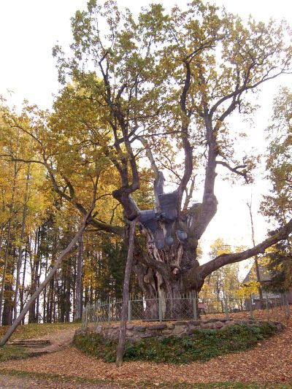

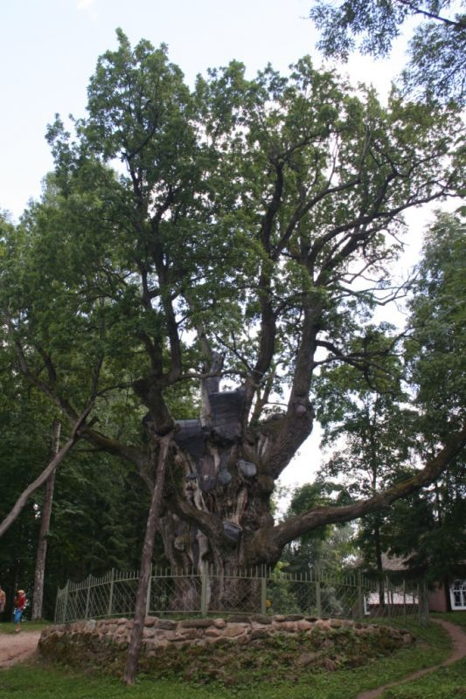
Bibliography

“White Oak” 08/28/00, updated 11/26/03 <http://www.floridata.com/ref/S/sorg_nut.cfm>.
“White Oak” 2001 <http://blueplanetbiomes.org/indian_grass.htm>
“Stelmuzes Azuolas” 2000<http://www.mmlab.ktu.lt/mmlab/Zarasai/muz/ms_eks_n.htm>

